6th EASP Meeting on the Psychology of Attitudes:
Social Processes of Evaluation

University of Bath
5 – 8 July, 2023

This meeting has been generously sponsored by

the European Association of Social Psychology,
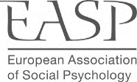

the Ohio State University,

and the University of Bath.
ORGANISATION

Organisational Committee:
Local:
Lukas Wolf (University of Bath)
Gregory Maio (University of Bath)
Geoff Haddock (Cardiff University)
External:
Pablo Briñol
Teresa Garcia-Marques
Anne Gast
Rob Holland
Richard Petty
Iris Schneider
Duane Wegener

How to get there

The meeting takes place at

The Edge
University of Bath
Claverton Down
BA2 7AY
Bath

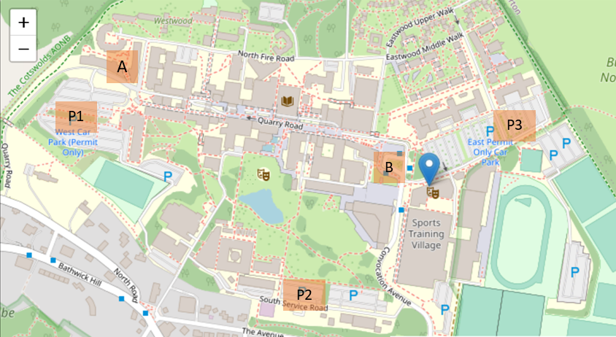
P2
P1
P3
B
A

Blue pin = Meeting place, The Edge
A = Accommodation in Polden
B = Main U1 Bus arrival square
P1-3 = on campus parking

How to get the bus from the Bath Spa station to the University

- When you arrive at the station, take the main exit towards Bath City centre.
- Outside the station, cross the street at the traffic lights and continue along the pavement (i.e., sidewalk) until you reach the U1 bus station (see map below)
- The U1 busses run every half hour and take about 15-20 minutes to reach the University of Bath terminal.

See the bus website for more detail and timetables: https://www.bath.ac.uk/guides/travelling-by-bus-to-the-university-of-bath/

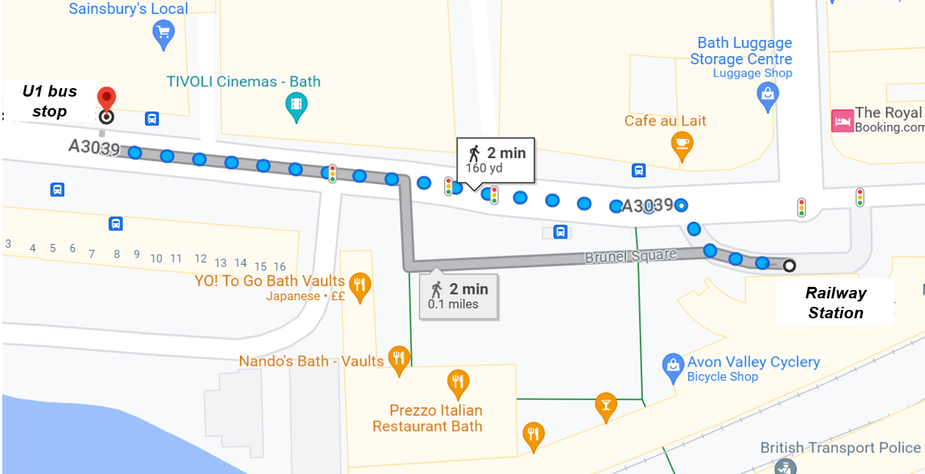

How to walk to Bath University campus

The walk offers beautiful panoramic views back across the City of Bath. It takes around 40 minutes – but it is uphill all the way!

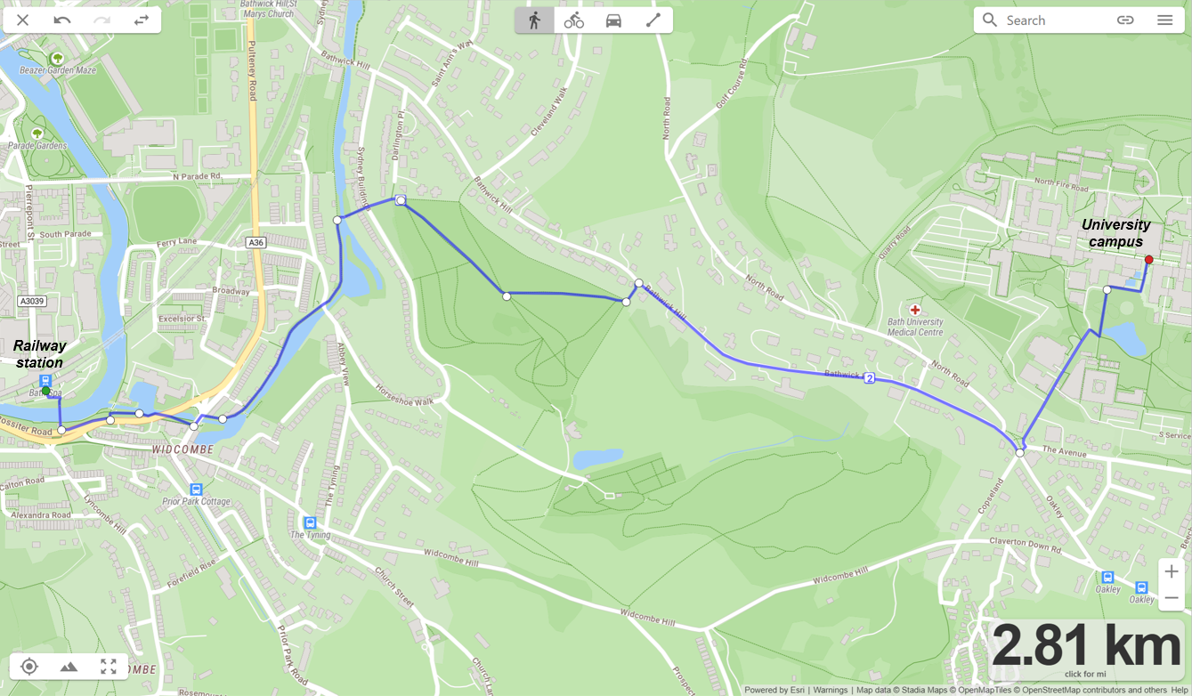

Dinner on Thursday, 6 July
The Architect

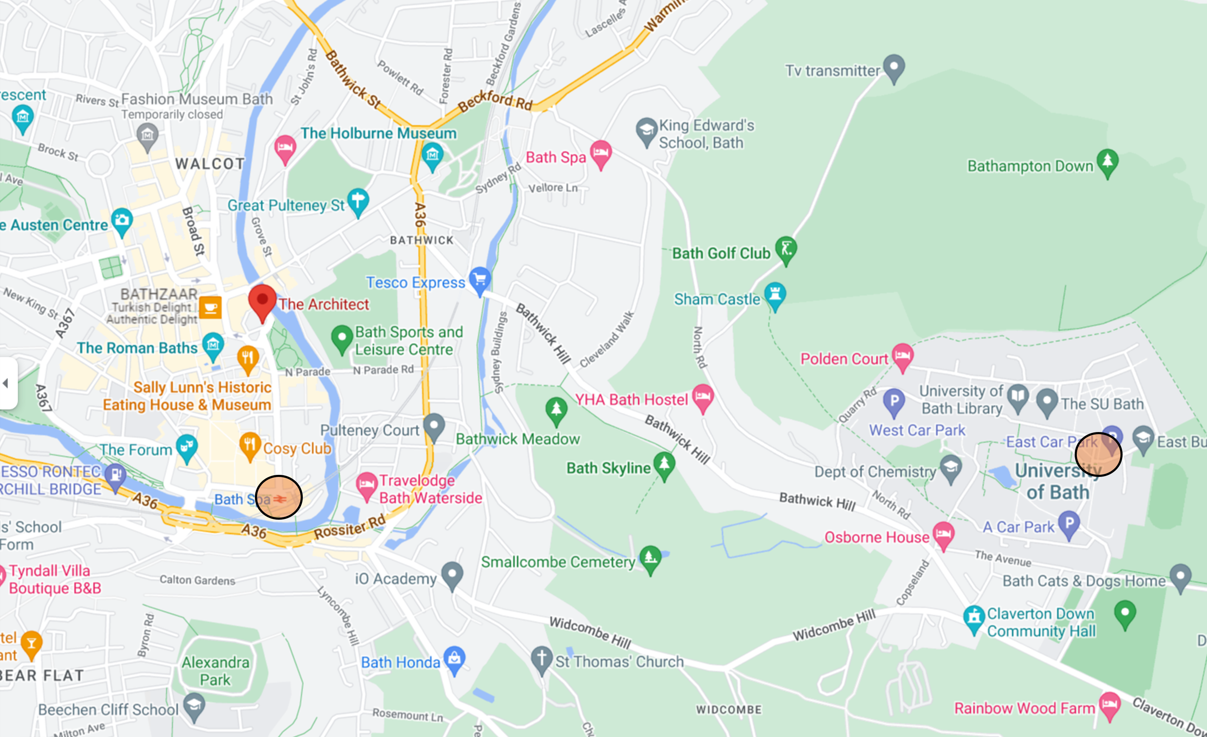

Format of talks

All presentations have the same format: 12-minute talks, followed by 1-2 clarification questions. There will be 9 sessions of 4-6 talks, organised under different themes as shown below in the programme.

Following each session, we’ll have a 30-minute discussion round covering the questions about the session. The audience can enter any questions they have about a talk or the session as a whole using the online platform Mentimeter, and these questions will then be discussed together.

Social events

Wednesday, 20:00: Welcome reception

Thursday, 15:15: Travel to Bath town
Thursday, 16:00: Roman Baths tour
Thursday, 18:30: Dinner at The Architect

Friday, 17:00: Free time, travel to Bath town
Friday, 18:30: Pub dinners in Bath town

Final lunch on Saturday 12:30
Wednesday, 5 July
From 11:00 on | Check-in and Conference Materials
20:00 | Welcome reception

Thursday, 6 July
9:00 – 9:15 | Coffee and Introduction
9:15 – 10:45 | Session 1: Attitude Strength  Chair: Rob Holland  Pablo Briñol (Universidad Autónoma de Madrid)  Hedonic vs. Epistemic Mindsets: Implications for Attitudes, Cognition, and Emotion  Lorena Moreno (Universidad Autónoma de Madrid)  Elaboration moderates reliance on attitude certainty.  James Hillman (Queen's University)  Miserable But Validated: The role of belongingness in attitude congeniality effects.  Jake Taylor (University of Arizona)  At least I don’t have that one! The role of attention and construal processes in post-decision dissonance.  Iris Schneider (Technical University Dresden)  Trust me; I’m ambivalent: The effect of expressed attitudinal ambivalence on trust.  Ruiqing Han (Cardiff University)  How people perceive (non-)ambivalent others and why it matters.
10:45 – 11:00 | Mid-morning refreshments
11:00 – 11:30 | Discussion
11:30 – 12:30 | Session 2: Human Motives  Chair: Jeff Stone  Lukas Wolf (University of Bath)  Correcting misperceptions of intergroup differences: Effects on polarisation and hope  Sam Taylor (University of Bath)  Shared attitudes vs values as predictors of wellbeing.  Aysheh Maslamani (Hebrew University of Jerusalem)  Feeling ambivalence about values.  Paul Conway (University of Southampton)  Standing up or giving up? Moral foundations mediate political differences in evaluations of Black Lives Matter and other protests.
12:30 – 13:00 | Discussion
13:00 – 13:45 | Box lunch
13:45-14:45 | Session 3: Attitude Formation 1  Chair: Geoff Haddock  Anne Gast (University of Cologne)  Evaluative conditioning in everyday settings  Tarini Singh (University of Trier)  Investigating attitude formation and memory in older adults.  Tjits van Lent (Radboud University Nijmegen)  Instrumental learning shapes the subjective value of ingroup and outgroup members’ faces  Joanna Wąsowicz (Polish Academy of Sciences)  Exploring the role of propositional processing in Evaluative Conditioning: Effects of cathodal tDCS of dorsolateral prefrontal cortex (dlPFC) on attitude formation
14:45 – 15:15 | Discussion and afternoon refreshments
15:15 | Travel to Bath town
16:00 | Roman Baths tour
18:30 | Dinner at The Architect

Friday, 7 July
9:00 – 9:15 | Coffee
9:15 – 10:45 | Session 4: Intergroup Contexts  Chair: Leaf van Boven  Paul Hanel (University of Essex)  Has actual political polarisation increased over time?  David Santos (IE University)  Perceiving cognitions and meta-cognitions of others  Eliana Buonaiuto (Flinders University)  When do people take the perspective of other group members? A meta-analysis of the effects of perspective-taking on intergroup attitudes and actions.  Sarah Smith (Cardiff University)  Reflections of Narcissus: Evaluations of the concept of narcissism, narcissistic acquaintances, and narcissistic faces are driven by perceiver narcissism.  Kate Ratliff (University of Florida)  The influence of legislative change on policy support and relevant intergroup attitudes  Gregory Maio (University of Bath)  Attitudes towards children: Distinguishing between affection and stress
10:45 – 11:00 | Mid-morning refreshments
11:00 – 11:30 | Discussion
11:30 – 12:30 | Session 5: Implicit Measures  Chair: Kate Ratliff  Adam Hahn (University of Bath)  You can bend it, but you can’t flip it: The limits of intentional control of IAT scores  Maximilian Primbs (Radboud University Nijmegen)  Implicit attitudes update immediately in response to societal events  Hannah Peetz (Radboud University Nijmegen)  Specificity in Measuring Implicit Attitudes – The Single Person Approach  Jeff Stone (University of Arizona)  Can people change their nonverbal behavior to reduce the expression of implicit prejudice? Some evidence that training and rehearsal may help.
12:30 – 13:00 | Discussion
13:00 – 13:45 | Box lunch
13:45-15:00 | Session 6: Attitude Formation 2  Chair: Paul Conway  Cristina Zogmaister (University of Milano-Bicocca)  Vicarious effects of approach/avoidance behaviours on observers.  Tal Moran (The Open University of Israel)  Attitudes of others moderate the effect of behavioral information on automatic and self-reported evaluations.  Janina Hoffmann (University of Bath)  Prior beliefs and belief-updating in social evaluations  Hadar Ram (Bar-Ilan University)  Psychological distance increases attitude generalization.  Joshua Tenn (University of Bath)  The wisdom of algorithmic crowds: How do decision-makers evaluate crowd-based algorithmic advice?
15:00 – 15:30 | Discussion and afternoon refreshments
15:30 – 16:30  16:30 – 17:00 | Session 7: Human Motives 2  Chair: Richard Petty  Leaf Van Boven (University of Colorado Boulder)  Analytic ecosystems increase trust in science and vaccine attitudes.  Thomas Vaughan-Johnston (Cardiff University)  Desired attitudes guide actual attitude change.  Borja Paredes (Universidad Autónoma de Madrid)  Confidence moderates attitude-identity-behavior dynamics.  Elena Magazin (Cardiff University)  The self-enhancement belief of traditional liberals and progressives.  Discussion
17:00 | Free time; travel to Bath town
18:30 | Pub dinners

Saturday, 8 July
9:00 – 9:15 | Coffee
9:15 – 10:15 | Session 8: Persuasion and Attitude Change 1  Chair: Duane Wegener  Richard Petty (Ohio State University)  The role of reciprocity in persuasion: Understanding one versus two-sided messages.  Teresa Garcia-Marques (ISPA-Instituto Universitário)  Is 'more' always better? Argument quality and quantity in persuasion.  Zakary Tormala (Stanford University)  Perceiving attitudes and attitude change: A categorical perspective  Guy Itzchakov (University of Haifa)  Can high-quality listening depolarize attitudes during disagreements?
10:15 – 10:30 | Mid-morning refreshments
10:30 – 11:00 | Discussion
11:00 – 12:00 | Session 9: Persuasion and Attitude Change 2  Chair: Gregory Maio  Maria Stavraki (Universidad de Castilla La Mancha)  Curiosity can not only increase processing but also decrease it depending on appraisals: Consequences for attitude change.  Anand Krishna (University of Würzburg)  Persuasiveness of nonverbal emotional expressiveness.  Duane Wegener (Ohio State University)  Discomfort as a motivator when misinformation is labeled as false.  Joel Cooper (Princeton University)  The influence of dissonance processes on health-related attitudes.
12:00 – 12:30 | Discussion and Closing Words
12:30 | Box lunch
 | Departure

ABSTRACTS

Session 1: Attitude Strength

Hedonic vs. Epistemic Mindsets: Implications for Attitudes, Cognition, and Emotion
Pablo Briñol, Universidad Autónoma de Madrid

Self-Validation Theory (SVT; Briñol & Petty, 2022) postulates that thoughts become more consequential for judgment and action as the perceived validity of the thoughts is increased. People come to rely on any thought more when they perceive that thought is likely to be true (cognitive validation) or because they just feel good about the thought (affective validation). In this talk, I will highlight how this distinction between cognitive and affective validation can be generalized across domains being relevant for understanding the effects of thoughts, attitudes, knowledge, emotions and beyond.

Elaboration moderates reliance on attitude certainty
Lorena Moreno, Universidad Autónoma de Madrid
Pablo Briñol, Universidad Autónoma de Madrid
Richard E. Petty, Ohio State University

The circumstances under which people are most likely to use their attitude certainty were examined. Across three studies, participants reported their attitudes toward current topics (e.g., Ukrainian refugees). Then, attitude certainty was either measured or manipulated, depending on the study. Elaboration was measured by assessing participants’ need for cognition or manipulated after forming attitudes and certainty and just before the behavioral decision. Attitudes, certainty, and elaboration served as predictors of different behavioral outcomes (e.g., actual enrollment in a mentoring program). As predicted, attitudes guided behavior. Furthermore, the greater the certainty, the greater attitude-behavior correspondence (ABC), replicating the traditional attitude strength effect. Most relevant, we found for the first time that the effect of already existing attitude certainty in moderating ABC was more likely to occur for high (vs. low) elaboration participants. Following Self-Validation Theory (Briñol & Petty, 2022), this research showed that elaboration can moderate not only the formation of metacognitive assessments but also the reliance on those previously formed assessments determining ABC.

Miserable but validated: The role of belongingness in attitude congeniality effects.
James Hillman, Queen's University
Tara MacDonald, Queen's University

Imagine a climate activist searching for information on climate change. Attitudinally congenial information is likely to be affectively negative (the climate crisis persists), but it would also be validating (their beliefs are correct). In contrast, uncongenial information will be affectively positive, but invalidating. We have suggested that the desire for validation stems from the need to belong (Hillman et al., 2022). Because belonging is a fundamental need, the desire to feel validated may take precedence over mood maintenance. Thus, people may be drawn to validating information even when it reduces their mood. We tested whether attitude congeniality biases persist in emotionally costly contexts, and whether belongingness underlies these effects. Studies 1-4 demonstrate a robust tendency for people to bias toward validating/negative news articles (even when it made them feel worse). Strength of biases were predicted by attitude extremity. Studies 5a/b found that inconsistency with social consensus led to stronger biasing toward validating/negative articles, while those who were socially consistent preferred unrelated/neutral articles. Study 6 tested the role of belongingness by manipulating ostracism using a Cyberball paradigm. Ostracized participants demonstrated stronger biases toward validating/negative articles than included participants. Together, these studies demonstrate that social consistency/belongingness needs exacerbate biases in information selection.

At least I don’t have that one! The role of attention and construal processes in post-decision dissonance
Jake Taylor, University of Arizona

Across 4 studies, we have found that when people focus on rejecting an alternative, they show less dissonance reduction (spreading) than when they accept an alternative (Brehm, 1956). This effect seems to be driven by a lack of bolstering when rejecting compared to when choosing. Study 5 attempts to test attention and discomfort as mediators for this effect. We expect that those rejecting an alternative will focus most of their attention on the “unchosen” alternative. This may be due to the inclusion of additional cognitions such as “at least I don’t have that one.” Conversely, we expect that those choosing will focus their attention equally on both alternatives. It has been assumed that participants focus on the positives of the “chosen” alternative and the negatives of the “unchosen” alternative (see Brehm, 1956). Further, we expect that those rejecting may experience less discomfort following their decision compared to those choosing. This is because they may be able to bring in that additional cognition stated above. This additional cognition should decrease the dissonance magnitude and impact the level of discomfort felt by those rejecting. Indeed, our meta-analysis revealed that those choosing both significantly bolster and derogate more than those rejecting.

Trust me; I’m ambivalent: The effect of expressed attitudinal ambivalence on trust.
Iris Schneider, Technical University Dresden
Angela Dorrough, University of Cologne

Many societal topics are a source of ambivalence. That is, instead of feeling only positive or only negative towards an issue, person, or topic, people experience both positive and negative thoughts and feelings. For instance, many people experience ambivalence about abortion, immigration, marihuana legalization, and windmill parks. This ambivalence is not only experienced by the self but also observed by others. How do others judge this ambivalence? We examine how perceptions of attitudinal ambivalence influence one of the most consequential social judgments, namely perceived trustworthiness and trust. In Study 1 (N= 280), participants were presented with information about a target's ambivalence towards different social issues. Results revealed that perceived trustworthiness was higher when targets expressed high ambivalence than low ambivalence. These effects were not moderated by the perceived controversy of a social issue. In Study 2 (N= 300), we examined trust in a behavioral paradigm using a trust game. Replicating Study 1, we found that participants sent more tokens to players who expressed high ambivalence about a societal topic than players who expressed low ambivalence. Moreover, target ambivalence influenced trust above and beyond attitude agreement between the players. Together, these findings show that expressed attitudinal ambivalence on societal topics can signal trustworthiness and elicit trust behavior in perceivers.

How people perceive (non-)ambivalent others and why it matters
Ruiqing Han, Cardiff University
Travis Proulx, Cardiff University
Frenk van Harreveld, University of Amsterdam
Geoff Haddock, Cardiff University)

“While research has studied the consequences of individual differences in dispositional attitude ambivalence, we know little about how dispositionally ambivalent and non-ambivalent targets are perceived. Across six experiments we examined how people perceive and mentally represent ambivalent and non-ambivalent others, and how people expect to interact with ambivalent and non-ambivalent targets. Experiment 1 demonstrated that a non-ambivalent target was expected to share less resources relative to ambivalent targets. Using a reverse correlation paradigm, Experiment 2 demonstrated that people have different mental representations of dispositionally ambivalent and non-ambivalent targets, which were evaluated differently on a range of outcomes. Experiment 3 demonstrated that participants could link descriptions of attitudinal ambivalence to representations of ambivalent and non-ambivalent faces. Experiment 4 demonstrated that a non-ambivalent target was perceived as most likely to be unfair to others. Experiment 5 demonstrated that representations of ambivalent and non-ambivalent targets influenced perceptions of the targets’ values, willingness to help others, and suitability for looking after a sick relative. Experiment 6 replicated Experiment 5 using verbal descriptions of targets’ ambivalence. Across experiments, warmth and competence mediated effects of ambivalence on outcomes. Overall, dispositionally ambivalent and non-ambivalent targets are perceived differently, and a target’s inferred ambivalence influences how they are evaluated.”

Session 2: Fundamental Human Motives

Correcting misperceptions of intergroup differences: Effects on polarisation and hope
Lukas Wolf, University of Bath
Paul Hanel, University of Essex

Two sets of studies examined effects of highlighting accurate value similarities between polarised, political groups on intergroup attitudes. In the first two studies (Study 1: N=1,506, Study 2: N=206), we found that Leave and Remain-voters in the aftermath of the UK Brexit referendum reveal an average of 90% overlap across a range of variables including fundamental, personal values. A subsequent experiment showed that using this information to highlight actual value similarities between the groups helped to correct misperceptions of group differences and reduced perceptions of polarisation. Another set of studies focused on US Republicans and Democrats, who also show substantial overlap in their values. Two experiments (Study 1: N = 403; Study 2: N = 973) found that compared to difference or baseline conditions, participants who received accurate similarity information expressed more hope about the future of the country in open-ended comments, and this effect was partially mediated by greater perceived similarity and reduced polarization around commonly divisive policies. Together, the findings suggest that it is possible to correct people’s misperceptions of fundamental differences with outpartisan voters, and that correcting these misperceptions can reduce polarisations around specific policies and elicit hope about the future.

Shared attitudes vs values as predictors of wellbeing
Sam Taylor, University of Bath

Research has demonstrated the positive effects of sharing values with others on wellbeing though increasing belongingness (e.g., Wolf et al., 2021). Equally, other findings show that sharing important, personally relevant (e.g., political) attitudes with others are also important to wellbeing, although mundane attitudes (e.g., towards beverages) are not (e.g., Bernard et al., 2006). However, little research has tested whether perceived similarity on the differential effects of sharing values compared with endorsing value-relevant attitudes. For example, people may feel less eco-anxious and more inspired to protect the environment if they believe that others in their area like to recycle and support car-free road policies, whilst perceiving general alignment with others on a more abstract, value level of “protecting the environment” may help generate a sense of greater meaning, purpose and belonging in life (e.g., Joshanloo & Ghaedi, 2009). This talk will discuss several studies investigating the consequences of shared attitudes and values on wellbeing, using polynomial regression and response surface analysis to provide simultaneous insights into the differential effects of perceived similarity of others’ attitudes and values to our own on our wellbeing, as well as direct effects of individuals’ own attitudes and values.

Feeling ambivalence about values
Aysheh Maslamani, Hebrew University of Jerusalem
In the area of social psychology, values are usually conceived of as “abstract ideals that are important guiding principles in one’s life” (e.g., Rokeach 1973, Schwartz 1992), and also as a cognitive representation of basic motivations – goals to be pursued. Accordingly, Sagiv et al. explains that “people can easily bring [values] to mind, reflect upon them, and consciously choose to pursue or ignore them in a situation” (2021, p.4). However, due to psychological obstacles which prevent us from inferring our own goals (e.g., Ferguson & Porter, 2010) and feelings (e.g., Schwarz & Clore, 1997), people may not be able to fully report their values when explicit measures are used. This difficulty may warrant exploring the undiscovered – automatic, unconscious, or inaccessible – facets of values. We propose that value ambivalence as a first step to explore the possibility regarding the existence of such further aspects of values that are undetected by explicit measures. Researchers have frequently highlighted values as a vital origin of conflicted or ambivalent attitudes (Rokeach, 1973; Tetlock et al., 1997). For example, conflicts between values have been highlighted as a source of ambivalence toward abortion (Craig et al., 2002), homosexuality and gay rights (Brewer, 2003), political candidates (Feldman, 1988), racial minorities (Katz & Hass, 1988). However, it could be that people also feel ambivalent about the value itself. In the current study we aim to examine if people feel ambivalence towards their values and whether we can link this ambivalence to value importance. 400 participants over 18 years from the UK complete a questionnaire where they have to scale their level of feeling positive/ negative towards values and then report their values. We ran a mixed-effect model with ambivalence, value type, and their interaction as fixed effects, with by subject random intercept, and by subject random slope for ambivalence. The results reveal that values which elicit less ambivalence predicted higher rating for value importance. Moreover, we got a significant interaction effect between ambivalence and value type. In other words, across ten different values, a low ambivalence value predicts a higher level of importance. However, after using the Benjamini correction, the effect of the value power disappeared. Meaning power value is rated as the least important value for the participants regardless of its’ level of ambivalence. We will discuss the findings and consider their implications for understanding the social psychological mechanisms underpinning value ambivalence.

Standing up or giving up? Moral foundations mediate political differences in evaluations of black lives matter and other protests
Paul Conway, University of Southampton
Isaac Richardson, Florida State University

Black Lives Matter (BLM) protests challenge the existing social order, whereas other protests do not (e.g., gun rights protests) or even reinforce it (e.g., Blue Lives Matter protests). Protests challenging the social order align with the ‘individualizing’ moral foundations (e.g., fairness, harm/care) but undermine ‘binding’ moral foundations (e.g., loyalty, authority), which may partially explain political differences in approval of protesting. Four studies (N=980) examined whether moral foundation endorsement mediated the effect of political orientation on protest evaluations. In Study 1, liberals rated BLM protests and general protesting as more moral than conservatives, partially due to increased individualizing and decreased binding endorsement. Studies 2-4 replicated this pattern for BLM and general protesting, but these effects disappeared for gun rights protests and largely reversed for Blue Lives Matter protests that uphold the status quo. These results suggest that protest evaluations partially reflect the moral values prioritized by different political groups.

Session 3: Attitude Formation 1

Evaluative Conditioning in everyday settings
Anne Gast¹, Jasmin Richter^{1,2}, Claudine Pulm¹, & Taylor Benedict¹
¹University of Cologne, Germany
²University of Oslo, Norway

Evaluative conditioning is often assumed to underlie many of the attitudes that play a role in our everyday lifes. Since evaluative conditioning consists of a change in valence that is due to pairings of a neutral stimulus (for example a person or a product) with a positive or negative stimulus (for example a likeable or dislikeable person, a negative news report, or an attractive landscape) one can argue that people might change their attitudes due to evaluative conditioning on a regular basis. We argue, however, that one may ask how adaptive such a general mechanism might be. Based on a Declarative Memory of evaluative conditioning (Gast, 2018), we argue that people need to retrieve the relevant stimulus pairings for an EC effect to occur. This in turn requires sufficient attention when observing the stimulus pairings. In this talk, I will present results from two paradigms with which we aim to investigate the role of evaluative conditioning in everyday settings. In the first paradigm, we presented across five studies picture-picture pairings to students during university lectures. Results from these studies suggest that evaluative conditioning effects in such a setting might be scarce and restricted to very attention-grabbing stimuli. In a second set of two studies, we investigated the role of retrieval processes in evaluating everyday objects. In line with the memory model of evaluative conditioning, we find that the attitude towards such everyday objects depends on the valence of previously experienced episodes, but only after retrieving these situations. I will discuss the implications of these studies.

Investigating attitude formation and memory in older adults
Tarini Singh, University of Trier
Siri-Maria Kamp, University of Trier
Eva Walther, University of Trier

Attitudes shape our behaviour and interactions with the environment. For instance, positive attitudes rather than negative attitudes towards the new neighbour are more likely to result in the adoption of a higher level of friendly behaviour towards this neighbour. Most research on attitude learning has been focused on research with children or younger adults. However, taking into account the prominent role of affect in older age, studying attitude formation in older adults is highly relevant. In the present study we investigated attitude formation in a sample of older adults (mean age 70 years, range 60 – 82 years), in an online setting. Using a standard evaluative learning paradigm, we found significant evaluative conditioning effects of the repeated co-occurrence of fictitious water brands with affect laden stimuli. Whereas the effects were strong for individuals with strong contingency memory, there were also small but significant effects for people with weak memory. Implication of these findings are discussed against the background of attitude formation theories.

Instrumental learning shapes the subjective value of ingroup and outgroup members’ faces
Tjits van Lent, Radboud University Nijmegen
Gijsbert Bijlstra, Radboud University Nijmegen
Rob W. Holland, Radboud University Nijmegen
Erik Bijleveld, Radboud University Nijmegen
Harm Veling, Radboud University Nijmegen

Generally, people assign lower subjective value to outgroup members’ faces, as compared to ingroup members’ faces. This phenomenon has the potential to lead to biased decision making, and thus, to hamper diversity. In four preregistered experiments (N=240), we examine whether and how people’s evaluations of other people’s faces—as well as the social decisions that ensue—can be modified through instrumental learning. In Experiment 1, we conducted a replication (Guitart-Masip et al., 2012), in which we replicated the action–valence asymmetry during learning using fractals as stimuli. People learned better to act when obtaining rewards than when avoiding punishments, while people learned better to not act when avoiding punishments than when obtaining rewards. In Experiments 2–4, we replicated these findings using social stimuli, using White–Dutch (Experiment 2), Moroccan–Dutch (Experiment 3), and both White–Dutch and Moroccan–Dutch faces (Experiment 4). Collectively, our experiments demonstrate that the action–valence asymmetry during learning influences subsequent subjective values of the faces. Also, our experiments suggest that these effects are similar in magnitude for ingroup and outgroup faces. We conclude that action–valence asymmetries occur during learning about social stimuli, and that these learning effects translate into social decisions.

Exploring the role of propositional processing in Evaluative Conditioning: effects of
cathodal tDCS of dorsolateral prefrontal cortex (dlPFC) on attitude formation
Joanna Wąsowicz, Polish Academy of Sciences
Robert Balas, Polish Academy of Sciences
Krzysztof Hanusz, Polish Academy of Sciences
Patrycja Uram, Polish Academy of Sciences

Evaluative Conditioning (EC) is a phenomenon in which a previously neutral stimulus acquires a positive or negative emotional response through repeated pairing with another stimulus that elicits such a response. While this effect is well-established, there is ongoing debate regarding its underlying nature. Two prominent theories are the associative theory, which suggests that evaluative change occurs through the formation of associations between the neutral stimulus (CS) and the affective stimulus (US), and the propositional theory, which proposes that this change involves the formation of propositional statements about the relationship between the stimuli. This study aimed to investigate the impact of cathodal transcranial direct current stimulation (tDCS) to the dorsolateral prefrontal cortex (dlPFC) on the formation of propositional statements during evaluative conditioning. The results of this study provide insight into the nature of attitude acquisition in EC and contribute to the ongoing discussion on the mentioned approaches.

Session 4: Intergroup Contexts

Has actual political polarisation increased over time?
Paul Hanel, University of Essex

Several studies found that affective polarisation between left-wingers and right-wingers increased the past years and decades. However, the extent to which polarisation actually increased is unclear. To close this gap, we investigated whether left-wingers and right-wingers have really become more dissimilar between 2002 and 2022 across 15 European countries (N = 300,000). Specifically, we found that left-wingers and right-wingers are overall more similar than different in their values (e.g., equality, freedom, safety) and their attitudes towards political institutions. Together, our findings indicate that political polarisation is more perceived than real.

Perceiving cognitions and meta-cognitions of others
David Santos, IE University
Pablo Briñol, Universidad Autónoma de Madrid
Richard E. Petty, Ohio State University

We present two lines of research relevant to reducing prejudiced attitudes. Both lines of research focused on the role of meta-cognitive processes of attitude change. In a first series of studies, we examined to what extent the perceived cognitions and meta-cognitions of others can influence prejudiced attitudes. Specifically, this research tested the impact of thinking about the cognitions and meta-cognitions of out-group members, including Syrian refugees, South American immigrants, and Roma people. In this research, we compared the impact of thinking about how members of out-groups usually think (perceived primary cognition) and how those members of those other groups think about their own thoughts (perceived secondary cognition). Compared to controls, these two treatments reduced prejudiced attitudes toward Syrian refugees, South American immigrants, and Roma people. After showing that metacognitive treatments can influence prejudiced attitudes, a second line of research examined to what extent a metacognitive treatment can also influence the stereotypical views of warmth and competence associated with different groups, such as rich or poor people. This research introduces a novel approach for researchers and practitioners interested in enhancing diversity through meta-cognitive processes of persuasion.

When do people take the perspective of other group members? A meta-analysis of the effects of perspective-taking on intergroup attitudes and actions
Eliana K. Buonaiuto, Flinders University
Emma F. Thomas, Mariette Berndsen, Lisette Yip, & Paul Williamson, Flinders University

Attitudes and behaviours are influenced by peoples’ social environments. Moreover, the expression of attitudes and behaviours are often governed by who we “stand with” at the time and within a specific context. Perspective-taking techniques are a unique way to understand how these processes are developed and maintained. However, despite considerable evidence supporting its efficacy, perspective-taking is also known to exacerbate negative attitudes in some contexts. We propose that the extent to which perspective-taking shapes attitudes and behaviours is contingent on the nature of relationships between groups (i.e., benevolent versus hostile); how perspective-taking is applied; and the intended outcome. We tested these propositions with a meta-analysis (k = 147, N = 21, 841) examining the impact of perspective-taking on intergroup attitudes, behaviours, and solidarity, to determine why perspective-taking produces varied effects. Findings show effects of perspective-taking depend on its application and intended outcome; and may exacerbate hostility towards some outgroups. I also explore how evaluations of different social groups, in turn, influence peoples’ willingness/ability to perspective-take with outgroup members. Results emphasise the importance of context when applying strategies to reduce hostile attitudes and behaviours. These insights can inform research and campaign practises aimed at developing strategies to attenuate hostile intergroup attitudes and actions.

Reflections of Narcissus: Evaluations of the concept of narcissism, narcissistic acquaintances, and narcissistic faces are driven by perceiver narcissism
Sarah Smith, Cardiff University
Geoff Haddock & Travis Proulx, Cardiff University

Across five studies (total N = 1,045) comprised of both student and general population samples, we demonstrate that attitudes towards narcissism and narcissists are linked to one’s own narcissism. In accordance with the narcissistic tolerance hypothesis (Hart & Adams, 2014), high (versus low) narcissism participants perceived self-generated narcissistic attributes more desirably, narcissistic (versus selfless) acquaintances more favourably (more warm, competent, likeable, and successful), and narcissistic (versus non-narcissistic) faces as more similar to themselves. Furthermore, we demonstrate that the positive association between perceiver narcissism and perceived similarity with narcissistic faces drives positive attitudes and behavioural expectations. This constellation of findings extends previous understandings of narcissistic tolerance by replicating its effects using novel methodological approaches (e.g., reverse correlation techniques). Additionally, the present studies bolster the external validity of the narcissistic tolerance hypothesis, moving beyond hypothetical vignettes of narcissistic characters, by demonstrating its influence on perceptions of real-world acquaintances. Overall, our results have important implications for understanding attitudes regarding narcissism and narcissists and the role of shared psychological traits between the perceiver and the perceived on interpersonal evaluations and behavioural intentions.

The influence of legislative change on policy support and relevant intergroup attitudes
Kate Ratliff, University of Florida

The goal of this research was to test the hypothesis that intergroup attitudes may be an outcome of institutional policy change. Study 1 experimentally demonstrated that perceivers make inferences about other people's policy preferences and relevant intergroup attitudes—in a variety of domains—based on the laws that are passed in the region in which they live. In a second, longitudinal study, we pursued a rare, time-sensitive opportunity to investigate the impact of federal and state policy changes on intergroup attitudes by assessing attitudes toward abortion and toward women before and after the U.S. Supreme Court’s ruling on Dobbs v. Jackson Women's Health Organization, the ruling that eliminated the right to abortion in the United States. The key finding from this study was that participants reported greater endorsement of traditional gender attitudes immediately post-ruling, compared to pre-ruling, and these changes in attitudes toward women persisted up to four months later. These results provide clear support for the idea that social processes—including institutional change and perceived norms—influence evaluation.

Attitudes towards children: Distinguishing between affection and stress
Gregory Maio, University of Bath
Lukas Wolf, University of Bath
Geoff Haddock, Cardiff University

Adult attitudes towards young people can vary from being supportive to shockingly abusive, and there are significant unanswered questions about the psychological factors underpinning this variability. Two sets of studies sought to address these questions by examining the content of adults’ attitudes towards children (10 studies; N=4,702) and teenagers (7 studies; N=5,731). Two factors emerged from adults’ descriptions of babies, toddlers, and school-age children: affection towards them and stress elicited by them. This factor structure was invariant across the UK, the US, and South Africa. Affection uniquely captures emotional approach tendencies, concern for others, and broad positivity in evaluations, experiences, motivations, and donation behavior. In contrast, stress relates to emotional instability, emotional avoidance, and concern about disruptions to a self-oriented, structured life. Adults’ descriptions of teenagers aligned with three factors: openness behaviours, negative beliefs, and positive emotions about teenagers. These factors also showed invariance across the UK, US, and South Africa, and they were uniquely linked with a range of variables including intergroup contact, social dominance, political orientation, and holding young people responsible for the spread of Covid-19. Together, these findings offer fundamental new insights about social cognitive processes in adults that impact children and teenagers.

Session 5: Implicit Measures

You can bend it, but you can’t flip it: The limits of intentional control of IAT scores
Adam Hahn, University of Bath
Clara Nicolina Bersch, Max Planck Institute of Human Development Berlin
Alexandra Goedderz, University of Cologne

Can individuals intentionally produce specific IAT scores? Previous research used a binary yes-or-no approach (show no bias vs. control) and yielded mixed results. To delineate the limits of how much control is possible, two preregistered lab studies (total N = 460) asked participants to produce randomly pre-assigned patterns of IAT scores in five different IATs and incentivized accurate production monetarily. Participants’ scores correlated with assignments only when assignments aligned with societal bias (e.g., bias against racial minorities). That is, participants were able to produce slightly less or slightly more bias as assigned, but not to reverse societal biases (e.g., show bias in favour of minorities). Further questions revealed that subjective experience of success in producing scores were uncorrelated with actual success in producing scores. Together, these findings suggest that control of IAT scores is possible but limited to slight variations within expectable levels of societal bias, while these societal bias levels continue to show; and that subjective experience of being able to trick an IAT may not be accurate.

Implicit attitudes update immediately in response to societal events
Maximilian Primbs, Radboud University Nijmegen
Rob Holland, Radboud University Nijmegen
Gijsbert Bijlstra, Radboud University Nijmegen

In recent years more and more attitude researchers started to recognize the importance of the social and cultural environment in the formation of attitudes (e.g., Murphy et al., 2013; Payne et al., 2017). In our modern world, this social and cultural environment is in constant flux: Changes in laws, policies, and social norms are a frequent occurrence. In this talk we will argue that implicit attitudes are sensitive to changes in the social and cultural environment and provide novel evidence that implicit attitudes can update immediately in response to societal events. Using data from on-going research projects, we will show that a) implicit attitudes can massively shift from one day to the next in reaction to an extreme societal event and b) implicit attitudes update regularly in response to re-occurring cultural events. We will showcase how we can use causal inference techniques from philosophy, economy and political science to draw causal inferences from natural experiments and argue that attitude researchers should make use of large, existing datasets to accelerate attitude research.

Specificity in Measuring Implicit Attitudes – The Single Person Approach
Hannah K. Peetz, Radboud University Nijmegen

Most research on implicit attitudes focusses on attitudes towards categories (e.g. African American), predicting behaviour related to these categories (e.g. helping behaviour towards an African American or support for BLM). However, implicit attitudes about a category do not seem to predict behaviour toward exemplars representing the category well (Kurdi et al., 2019), which might be in part due to the incongruency between the measured attitude at category level and the behaviour toward an individual (Ajzen & Fishbein, 1977). In recent years, research has started to examine implicit attitudes towards individuals as well as the behavior towards those individuals (Krause et al., 2014; Faure et al., 2018; Lansu 2018), thus increasing the specificity of the measured attitudes. The present project aims to validate the Single Person Approach of measuring implicit attitudes. In a sample of children, we assessed implicit attitudes towards specific classmates as well as their behavioural intentions and non-verbal behaviour towards these same classmates. The Single Person Approach will be discussed from both a theoretical and a methodological perspective.

Can people change their nonverbal behavior to reduce the expression of implicit prejudice? Some evidence that training and rehearsal may help.
Jeff Stone, University of Arizona
Jake Taylor, University of Arizona
Katie Wolsiefer, Appalachian State University
Han Yu Lu, University of Arizona

During intergroup interaction, research indicates that people express implicit prejudice through negative nonverbal behaviors such as less smiling, head nodding, or eye contact, which leads marginalized interaction partners to form negative impressions of them (Dovidio et al., 2002; Hagiwara et al., 2020). This research examines if people with high implicit prejudice can learn to express positive nonverbal behaviors that will lead to more positive impressions between interaction partners. In Study 1 (N = 94), participants completed an anti-Muslim IAT, and then half learned how to express warmth nonverbally while interacting with a Muslim confederate. Results showed that despite reporting higher intentions than the control, trained participants did not express the positive nonverbal behaviors during the interaction. In Study 2 (N = 110), when half of the participants rehearsed the positive nonverbal behaviors before the interaction, the Muslim confederates reported more positive impressions compared to the control, and trained participants high in implicit prejudice felt more prepared and effective after the interaction. There were no effects on impressions of the confederate or on anti-Muslim implicit prejudice. The discussion focuses on what steps may be necessary for people to adopt more positive nonverbal behaviors to reduce their expression of implicit prejudice.

Session 6: Attitude Formation 2

Vicarious effects of approach/avoidance behaviours on observers
Cristina Zogmaister, University of Milano-Bicocca
Michela Vezzoli, University of Milano-Bicocca
Karoline Bading, Friedrich-Schiller-University Jena
Marco Perugini, University of Milano-Bicocca

Social learning is important for attitude formation. By learning how others (“models”) behave toward target objects, individuals can form their own attitudes. Previous research has shown that observing a model’s emotional reaction can influence how the observer evaluates a target stimulus (observational evaluative conditioning). Our results indicate that such learning effects also emerge with approach/avoidance-related behaviours.
Through 5 experiments, we investigated how learning information about the behaviours of other individuals influenced participants’ own preferences. In these experiments, participants read a vignette describing a fictitious character approaching a food brand and avoiding another. Next, they answered an IAT and a semantic differential that measured the preferences between the two brands. Results showed that participants preferred the approached brand, both in self-reported and spontaneous preferences (vicarious approach/avoidance effect). This vicarious effect was robust because it also emerged when participants were informed that the model was a mere executor (i.e, the decision as to which object to approach and which to avoid was determined by a coin toss).
Besides their theoretical implications regarding attitudes and attitude change, these results also have potential practical implications for developing interventions aimed at attitude formation and protecting the public from unwanted persuasion attempts.

Attitudes of others moderate the effect of behavioral information on automatic and self-reported evaluations.
Tal Moran, The Open University of Israel

Conformity refers to the act of changing one’s response to match the responses of others. Two preregistered studies tested the sensitivity of both automatic (IAT) and self-reported evaluation to conformity processes. Participants learned positive behavioral information about one man and negative behavioral information about another man. Additionally, participants received information about how other participants rated the two men after being exposed to the same information. The others’ ratings were either congruent or incongruent with the behavioral information. Study 1 (N= 492) provided behavioral information before others' ratings were presented, while Study 2 (N= 397) provided behavioral information after others' ratings were presented. Both studies found that others’ attitudes influenced automatic and self-reported evaluation. The preference for the positive man was weaker when others’ ratings were incongruent (vs. congruent) with the behavioral information. In both studies, participants' memory regarding behaviors' valence was less accurate when others' ratings were incongruent with the behavioral information. The effect of others’ attitudes remained significant in a sub-sample of participants with accurate memory only for the automatic evaluation measure in Study 2. Results suggest that others' attitudes moderate the effect of behavioral information on automatic and self-reported evaluations.

Prior beliefs and belief-updating in social evaluations
Janina A. Hoffmann, University of Bath
Catherine Hobbs, University of Bristol
Michael Moutoussis, University College London
Katherine S. Button, University of Bath

In professional and personal life, individuals often need to adjust their own beliefs and knowledge from the advice and feedback other persons provide. When meeting someone new, for instance, we learn from praise or criticism how much our new acquaintance likes us. Individuals differ in how successfully they revise their initial beliefs. Belief revision may fail because individuals initially hold wrong prior beliefs, or because they are resistant to change their beliefs, or both. For instance, individuals in poor mental health may detect faster that another person dislikes them because they initially hold a negative self-image or because they learn faster from negative feedback. In a reanalysis of previous studies (n = 450) and a preregistered study (n = 807), we investigated which mechanisms best describe social evaluation learning across associative learning and belief updating models. We find that an initial positive (relative to a negative) self-image explains better than learning speed why some individuals appear to learn faster who appreciates them. Further, initial beliefs are a reliable precursor of psychopathological traits and correlate predictably with depressive symptoms and fear of negative evaluation. We discuss how those belief updating mechanisms can be integrated into interpersonal models of attitude formation.

Psychological distance increases attitude generalization.
Hadar Ram, Bar-Ilan University
Nira Liberman, Tel Aviv University
Christian Unkelbach, University of Cologne

Attitude generalization is a fundamental process whereby people use past positive and negative experiences in making judgments and decisions about different yet related stimuli and situations. In the current research, we explored how attitude generalization is affected by psychological distance. More specifically, we predicted and found in four experiments (N = 1,211) that psychological distance increases conceptual generalization. We manipulated psychological distance by describing a product as being either domestic (proximal) or foreign (distal) and examined generalization by testing how information about initial experience (positive versus negative) with the same product influences evaluations of similar products. First, we demonstrated that when a product is foreign (vs. domestic), the potential target objects of generalization (i.e., additional products) are perceived as more psychologically distant. Then, in three experiments, and across both Israeli and German participants, we found that people generalized from experience with products that are distal (foreign) more than from proximal (domestic) products. We explain the relation between distance and generalization in terms of the accuracy-applicability tradeoff inherent in generalization and discuss how it aligns with construal level theory.

The wisdom of algorithmic crowds: How do decision-makers evaluate crowd-based algorithmic advice?
Joshua J Tenn, University of Bath
Janina Hoffmann, University of Bath

Despite the increasing popularity and accuracy of algorithmic recommendations, decision-makers rarely succeed at using algorithmic advice appropriately, either under-utilising it relative to their own judgement (algorithm aversion) or showing an over-reliance (algorithm appreciation). Previous research has indicated that estimates from human crowds are often evaluated more favourably than individual estimates, due to social processes such as informational social influence, and can lead to greater judgement accuracy if used. Our research aims to understand whether using ‘algorithmic crowd’ estimates can similarly affect the evaluation and use of algorithmic advice. Participants will first forecast individuals’ health insurance costs in an initial ‘learning phase’. Later in the experiment, after making an initial estimate, participants will be presented with advice from either a single advisor (decision tree) or algorithmic crowd (random forest), and are asked to make a revised estimate. We expect that participants’ weight on advice and judgement accuracy will be higher when receiving algorithmic crowd advice due to more positive evaluations. As exploratory analyses, we plan to compare our results to cognitive models of advice evaluation based on different processes (social influence, egocentric bias) to understand the mechanisms behind any differences in advice evaluation between conditions.

Session 7: Human Motives 2

Analytic ecosystems increase trust in science and vaccine attitudes
Leaf Van Boven, University of Colorado Boulder
Guilherme Ramos, FGV EBAPE Brazilian School of Public and Business Administration
David Sherman & Heejung Kim, University of California, Santa Barbara
David Markowitz, University of Oregon
Ellen Peters, University of Oregon

We introduce the concept of an Analytic Ecosystem, which includes four factors that influence people’s trust in science and, consequently, their vaccine attitudes and behaviors. The ecosystem comprises analytical abilities, analytical or intuitive thinking style, the analytic language of the media people consume, and perceived social norms regarding others’ analytical orientation. All four components of the analytical ecosystem increase personal trust in science and perceived social norms regarding trust in science, which, in turn, increase personal attitudes toward vaccines and social norms regarding vaccines to influence vaccination behavior. Two pilot studies provide supporting evidence. One longitudinal study found that both analytical ability and consuming analytical media predicted trust in science and subsequent attitudes and behaviors regarding COVID-19 vaccines, as well as reducing political divisions in the United Kingdom and the United States. Another study found that all four analytical ecosystem components predicted trust in science and attitudes and behaviors regarding flu vaccines among university students. The analytical ecosystem framework and supporting pilot studies highlight the independent and vital contributions social-informational environments in supporting attitudes and behaviors to address global public health challenges.

Desired attitudes guide actual attitude change
Thomas I. Vaughan-Johnston, Cardiff University
Leandre R. Fabrigar, Queen’s University
Ji Xia, University at Buffalo
Ken DeMarree, University at Buffalo
Jason Clark, University of Virginia

People often learn that a favorite artist has violated societal norms, generating a feeling of tension between their actual opinion (e.g., “I like this song”) and their desired opinion (e.g., “I wish I didn’t like this song”). Such actual/desired attitude discrepancies have been widely studied (DeMarree et al., 2014, 2017). However, effects of desired attitudes on actual attitude change have surprisingly not been studied. In three experiments, we manipulated desired attitudes through a novel paradigm in which people formed attitudes towards a painting before learning that the painting was made by a morally good (Nazi resister) or bad (Nazi sympathizer) individual. We then examined how people changed their actual attitudes as guided by their desired attitudes by engaging in biased metacognition (i.e., liking and trusting thoughts congruent with the desired attitude goal). In the third experiment, we “froze” actual attitudes before exposing people to the same paradigm, and showed that people’s value clarity became disrupted when they were unable to shift their reported attitudes in line with their desired attitudes. This research therefore reveals a novel consequence of desired attitudes (i.e., guiding self-persuasion), a novel mechanism (i.e., biased metacognition), and an underlying motivation (i.e., to avoid disruptions in value clarity).

Confidence Moderates Attitude-Identity-Behavior Dynamics
Borja Paredes, Universidad Autónoma de Madrid
Lorena Moreno, Universidad Autónoma de Madrid
Ana Grande, Universidad Autónoma de Madrid
Pablo Briñol, Universidad Autónoma de Madrid
Richard E. Petty, Ohio State University

This research examined when and for whom attitudes toward a group are more likely to impact identity with that group. In a first line of research, three studies examined the effect of attitude confidence on moderating the relationship between attitudes and identity. Participants’ attitudes toward a group were first measured. Then, the confidence in participant’s attitudes was either measured (Study 1) or manipulated through an incidental confidence induction (Study 2). Attitudes and attitude confidence served as predictors of group identity across three different domains (e.g., identity fusion with a group of friends, with a consumer brand, and science identity). Study 3 manipulated attitudes to stablish causal evidence of their predictive validity in this domain. As expected, group attitudes were associated with group identity in all studies. Most relevant, results showed that attitude confidence moderated attitude-identity correspondence (i.e., the greater the certainty in one´s group attitudes, the greater relationship between attitudes and identity). Confidence can not only moderate the relationship between attitudes and identity, but it can also moderate the ability of any mental construct and its subsequent outcome. Therefore, in a second line of research we revealed that the same measures and inductions of confidence used in the first group of studies improved also the predictive validity of group identity on subsequent identity-relevant attitudes and behaviors.

The self-enhancement belief of traditional liberals and progressives
Elena Alexandra Magazin, Cardiff University
Travis Proulx, Cardiff University
Constantine Sedikides, University of Southampton

The aim of this research was to explore potentially differing self-enhancement beliefs held by distinct left-wing identities: Progressives and Traditional Liberals. Previously, we developed the Progressive Value Scale (PVS) to differentiate between these cohorts and showed that those scoring higher in its Public Censure facet were also more assured in their superior understanding of others. Consequently, we sought to investigate the extent to which Progressives and Traditional Liberals differ in their broader self-enhancement. 284 left-wing Cardiff University students completed the PVS, along with measures related to self-enhancement or positive illusions: Communal Narcissism Index (CNI – grandiosity in communal domains), General Belief Superiority Scale (measuring belief superiority across five domains), Social Vigilantism (capturing an obligation to “correct” ignorant beliefs), as well as a Psychological Entitlement Scale (measuring entitlement/deservedness). Our findings revealed a significant positive correlation between the PVS and social vigilantism and belief superiority (relating to politics). However, there was a significant negative relationship between the PVS and CNI as well as entitlement scores. Overall, the findings imply that while both Progressives and Traditional Liberals self-enhance, Progressives self-enhance in relation to others. Progressives, thus, have a superior attitude about their own knowledge and also show a greater desire to propagate those beliefs.
Session 8: Persuasion and Attitude Change 1

The role of reciprocity in persuasion: Understanding one versus two-sided messages
Richard E. Petty, Ohio State University, USA
Mengran Xu, Fudan University, China

Research on persuasion in social contexts has demonstrated that people are more influenced by a source who has previously yielded to their own message (Cialdini, et al., 1992). This suggested that if a message recipient merely believed that the source had yielded to some of the arguments on their own side, they would reciprocate by being more open to influence from the source compared to when the source did recognize their side. Furthermore, we expected this reciprocity to be greater when people were deeply committed to their own positions because in this case the concession the source made would be appreciated more. We operationalized the invocation of the norm of reciprocity by having the source present either just counterattitudinal arguments (one-sided message), or a message that also recognized the validity of some arguments on the recipient’s side (two-sided message). Across 9 experiments using various topics and messages that operationalized attitude strength in various ways (e.g., morality, certainty, group identity) we found that as attitude strength increased, people became more open to persuasion when a two- rather than one-sided message was presented. Evidence for various inter- (reciprocity) and intra-personal (self-affirmation) processes are presented along with moderating factors (e.g., need for approval).

Is 'more' always better? Argument quality and quantity in persuasion.
Teresa Garcia-Marques, ISPA-Instituto Universitário

Previous research suggests that both argument quality and quantity play an important role in persuasion. Consistent with the Elaboration Likelihood Model (ELM), a seminal study by Petty and Cacioppo (1984) showed that people who are less involved with a message rely more on argument quantity whereas those who are more involved rely on argument quality. In the latter case, quantity may be either disregarded or it can magnify the positive or negative impact of argument quality. While several studies have consistently corroborated the relevance of argument quality when participants are elaborating on the message, less attention has been given to the role of argument quantity, and the studies that have focused on quantity have suggested other roles by which it can influence persuasion. In this communication, we present the results of a set of studies that examine quantity both as message length and the number of arguments in a message and the relationship of its effects with the subjective ease of processing the message content and the explicit beliefs that "more is better" and "quality is not quantity." We discuss how these results contribute to a better understanding of the multiple roles by which a single variable can influence the persuasive process.

Perceiving attitudes and attitude change: A categorical perspective
Zakary Tormala

Attitude change and persuasion are among the most studied topics in social psychology. Interestingly, though, as a ﬁeld we have very little insight into a fundamentally social aspect of change: how people perceive and assess the magnitude of a shift in someone’s attitude or opinion. Across numerous experiments, we investigate this issue. First, we find consistent support for a categorical perspective, whereby categorical (or qualitative) attitude change (change of valence; e.g., from negative to positive) is perceived as greater than non-categorical (or non-qualitative) attitude change (change within valence; e.g., from moderately to extremely positive). This effect is mediated by ease of processing and has implications for persuasion targeting, attitude-behavior correspondence, and receptiveness to disagreeing others. People are more likely to target others for persuasion when they believe they can change their attitudes across rather than within valence. Likewise, the slope of the attitude-behavior relationship is steeper as attitudes move across rather than within valence. Finally, people are less receptive to others whose attitudes differ from theirs across rather than within valence. These findings offer insight into both classic (What affects the attitude-behavior relationship?) and contemporary (What stimulates advocacy? What drives political divisiveness?) questions in attitudes research.

Can high-quality listening depolarize attitudes during disagreements?
Guy Itzchakov, University of Haifa
Netta Weinstein, University of Reading
Mark Leary, Duke University
Dvori Saluk, University of Haifa
Moty Amar, Ono Academic College

Disagreements can polarize attitudes when they evoke defensiveness from the conversation partners. When the speaker talks, the listener often thinks about how to counterargue. This process often fails to depolarize attitudes and might even backfire (i.e., the Boomerang effect). However, what would happen in disagreements if the listener genuinely listened to the speaker's perspective instead of thinking how to counterague? We hypothesized that when listeners convey high-quality listening, characterized by attention, understanding, and positive intentions, their speakers will feel more socially connected to them (measured by positivity resonance) and will be able to reflect in a nondefensive manner about their attitudes. We further hypothesized that this process would lead to reduced perceived depolarization (perceived attitude change, perceived attitude similarity with the listener) and actual polarization (reduced attitude extremity). Four experiments manipulated poor, moderate, and high-quality listening and included a video vignette (Study 1) and three live interactions (Studies 2-4). These experiments consistently supported the research hypotheses and the serial mediation model. Moreover, the effect of the listening manipulation on perceived and actual depolarization was not moderated by attitude strength constructs, namely, attitude certainty and attitude morality. This project suggests that high-quality listening can be a valuable tool to bridge divides.

Session 9: Persuasion and Attitude Change 2

Curiosity can not only increase processing but also decrease it depending on appraisals: Consequences for attitude change
Maria Stavraki, Universidad de Castilla La Mancha
Grigorios Lamprinakos, University of Birmingham
Miriam Bajo, Universidad de Castilla La Mancha
Pablo Briñol, Universidad Autónoma de Madrid;
Richard Petty, The Ohio State University

The present work examines, for the first time, curiosity (a positive emotion associated with doubt) compared to boredom and disgust (negative emotions associated with confidence). In two studies (N = 801) we predicted and found that curiosity, boredom, and disgust can each lead to different levels of information processing of persuasive proposals depending on the appraisal that is salient within the emotion. Specifically, focusing participants on the pleasantness that accompanies induced curiosity, led to relatively lower levels of processing of the persuasive proposal (as indicated by less argument quality effects on attitudes) compared to focusing on the doubt appraisal also associated with that emotion. When participants induced to feel curiosity (vs. boredom, and disgust) focused on the appraisal of doubt, they processed the persuasive proposal to a relatively higher degree (as indicated by increased argument quality effects on attitudes). The opposite was found for boredom and disgust. Focusing on the unpleasantness associated with boredom and disgust increased processing, while focusing on the confidence appraisal of those emotions decreased processing compared to curiosity. These effects were mediated by changes in thought favorability and were consequential for attitude strength (as indicated by greater attitude-behavior correspondence observed for high vs. low thinking conditions).

Persuasiveness of nonverbal emotional expressiveness
Anand Krishna, University of Würzburg
Comparatively little research has examined how nonverbal emotional expressivity can affect source credibility judgments. In four experiments, participants viewed videos of expressive vs. nonexpressive persuasive speakers before reporting perceived speaker
credibility. An initial application of language expectancy theory to nonverbal behavior in persuasion predicted that experts should benefit from emotional expressivity, whereas laypeople should be hindered by it. Two studies (total N=207) did not support this prediction, but the second showed that expressive individuals were perceived as more
trustworthy, yet also more biased, regardless of expertise. A subsequent experiment (n=121) examined motivated cognition due to pre-existing agreement with the speaker as a determinant of whether expressivity leads to positive (trustworthiness) or negative (bias and reduced competence) perceptions, but found no evidence for motivated inferences from expressivity. A final experiment (n=113) tested whether effects of expressivity unfold via emotional contagion processes rather than inferences. Results supported an inferential view of expressivity effects in persuasion, raising the question of why these inferences are robust to motivated cognition effects. While some questions remain open, these findings underline the importance of a speaker’s expressivity for their credibility.

Discomfort as a motivator when misinformation is labeled as false
Duane T. Wegener, Ohio State University
Mark W. Susmann, Ohio State University

Many explanations for continued belief in misinformation after it is labeled as false rely on cognitive mechanisms. However, when misinformation is labeled as false, people can be motivated to continue to believe the misinformation, especially if there is a reason for them to want the misinformation to be true. One such reason could be that the misinformation is consistent with existing attitudes or beliefs. A series of studies documents links between attitude consistency of misinformation and discomfort when the misinformation is corrected as well as the role of discomfort as a motivator of continued belief. This evidence includes causal evidence for discomfort as well as consequences beyond continued belief per se.

The influence of dissonance processes on health-related attitudes
Joel Cooper, Princeton University

It is becoming increasingly clear that people’s attitudes toward their own health play a crucial role in determining physical and psychological morbidity. Attitudes toward diet and exercise, for example, influence the degree to which people engage in activities that promote health. Yet, attitudes toward health seem remarkably resistant to long-term change. In this talk, I will suggest that among the social processes that make people resist change is cognitive dissonance. However, I will suggest that cognitive dissonance can be leveraged in creative ways to overcome resistance and exert motivation for healthy change. I will argue that dissonance can be activated to create the attitude and behavior change necessary for improved health. I will discuss some empirical finding from our lab that show a dramatic effect of dissonance processes on influencing attitudes toward COVID-19 precautions, as well as other findings that show the effect of dissonance on improving attitudes and behaviors toward healthy eating and exercise.

